**Hierarchical Inheritance**

In such kind of inheritance one class is inherited by many **sub classes**. In below example class B,C and D **inherits** the same class A. A is **parent class (or base class)** of B,C & D.

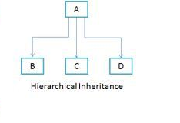 **class** A

{

**public** **void** methodA()

{

System.***out***.println("method of Class A");

}

}

**class** B **extends** A

{

**public** **void** methodB()

{

System.***out***.println("method of Class B");

}

}

**class** C **extends** A

{

**public** **void** methodC()

{

System.***out***.println("method of Class C");

}

}

**class** D **extends** A

{

**public** **void** methodD()

{

System.***out***.println("method of Class D");

}

}

**class** Z

{

**public** **void** methodB()

{

System.***out***.println("method of Class B");

}

**public** **static** **void** main(String args[])

{

B obj1 = **new** B();

C obj2 = **new** C();

D obj3 = **new** D();

obj1.methodA();

obj2.methodA();

obj3.methodA();

}

}

**Output**

method of Class A

method of Class A

method of Class A